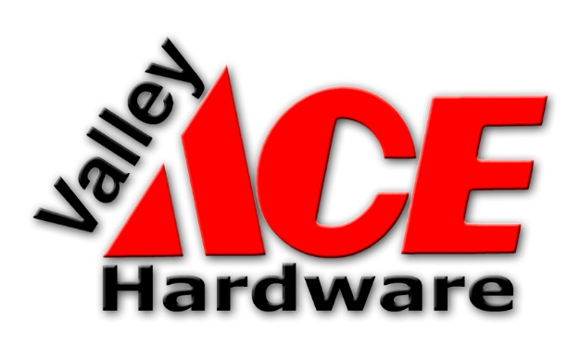
Example 2 Day
Strategic Plan Retreat
Agenda

Remember: PREPARE YOUR FLIPCHARTS BEFORE YOU ARRIVE! Here are the minimum ones I prewrite. DO NOT wait until the morning of, or when you are facilitating – you will waste time and be ineffective.

- Agenda
- Ground Rules
- Consensus
- Parking Lot
- Next Steps
- Agreements
- The main charts you will use. In the case of strategic planning, that includes:
- Current Culture
- Preferred Culture
- Values
- What’s Working Well?
- What’s Not Working Well?
- Biggest Challenges
- Priorities
- Mission
- Vision
- Goals
- Action Steps

Tuesday February 11th and Wednesday, February 12th
Location: Hermit Basin Lodge
Breakfast at 8:00
Meeting from 9:00 – 4:00 each day

BRING: Growth Strategies presentation, Strengthsfinder results

Purpose of the Retreat: Together as a team, to craft a Strategic Plan for Valley Ace that will align with corporate Goals and create long term success.

Goals for Valley ACE: to be the dominant competitor in the areas/products of service we offer and create such a barrier to entry in the Valley that no one becomes a competitor. We will do that by focusing on employees as the foundation of our success. Our strategic advantage is customer service.

Day One: Tuesday, February 11th

8:00 Breakfast will be available
I also always have some sort of teambuilding exercise (see list in Monday.com) for people to participate. Note: the human brain will see the first time on the agenda, so even if there isn’t food or a game, it’s recommended to have this first time on the agenda be at least 15 minutes before the meeting starts.
9:00 Welcome and Purpose
This is the opportunity to engage people, get them excited from the very beginning, and let them know how important they are to the process. It’s best to get some sort of non verbal “engagement” immediately (ask a “raise your hand” question, or a “nod if you agree” question)
9:05 Agenda for the Day
Always have a printed agenda for them, I also write it on a flip chart so that as I go through the day I can literally ask them if we covered it, and cross it off.
9:15 Ground Rules
See the Facilitation Manual for a good range of ground rules. This is where you also need to cover the meaning of consensus – and ask them for consensus on the ground rules.
9:20 Setting the Stage
Here you can cover the general approach (how people learn differently, how people think, how people engage)
9:30 Introductions
I always introduce myself more and ask them to do the same. I usually use the conversation cards here – they likely know each other very well, but the questions are awesome! Also, this will tell you a lot about them: do they talk a lot? One word answers? Relationship oriented? This allows you to take the “temperature” of the room and the measure of the person.

9:45 The Strategic Journey: Road Map/Definitions
If this is a strategic planning session, here is the place to use the Road Map, and talk about the language of a strategic plan. If this is another type of session, it’s the time to cover any meanings or acronyms.
10:00 Values and Culture
You should start with some very movement oriented. The rule is usually to start with some brainstorming to warm people up – you are still writing, but they are participatory and it gets them involved and active. If this is a strategic planning session, Values are a great way to get conversations started, and break the team in to random groups.
10:30 Break – EVERY 90 minutes is the rule, I try for a 15-minute break
10:45 Strengthsfinder
We use Strengthsfinder as our tool – so if I’m doing teambuilding, it’s a good time to cover those strengths. I put this before lunch so conversations can continue.
12:15 Lunch Break – at least 30 minutes
12:45 Survey and Interview Results
I never lead with results – it’s boring to me and I prefer to start with sometime less presentation oriented and more movement oriented.
1:15 Valley ACE Mission
Mission is easier to facilitate than Vision for most people – see the Mission handout on Monday.com for some ideas of how to proceed.
1:45 Vision: Retail Store of the Future
Vision can be more difficult, because it’s very big picture and touchy feely. See the Vision handout in Monday.com. I also ask questions like: How would it feel? What would you see? How would you describe it to someone who hasn’t seen it/been here for 15 years?
2:15 Break
2:30 Areas of Focus/Priorities/Pillars/Critical Success Factors
Start with brainstorming a long list, then use any technique that works to “vote” on that long list. I use colored dots to weight the responses and determine the top 3 – 5.
3:30 Agenda for Tomorrow
3:45 Wrap up and Close – Note – with a 6 hour session, only about 4 hours is actual work (breaks, fun things and other issues take up the other 2 hours). I prefer to stop at 3:00 in the afternoon, as I normally find people just get too frazzled after that hour of the day.

Day Two: Wednesday, February 11th

8:00 Breakfast is available – again, I always try to give the team something to “compete” or work on.
9:00 Welcome and Purpose
ALWAYS cover the same “introductory items” from the first day: purpose, ground rules, consensus, and any other agreements.
9:15 Quick Review of Tuesday
This is a soft and easy way to remind them and set the stage
9:30 ACE Corporate Goals and Expectations
This was specific to the client, but it’s based on discussions
10:30 Break
10:45 Growth Strategies/Goals by Area (Presented by Managers)
11:15 Team Expectations: Communication, Accountability
I will usually do a team exercise here to reinforce strengths or issues they face.
11:45 Goals
For each Area of Focus/Priority/Pillar/Critical Success Factor we try to create 2- 3 Goals.
12:15 Lunch Break
12:45 SWOT for the Goals
It’s a good idea, if you have a team that can think critically, that you allow them to discuss each Goal to talk about:
Strengths/Weaknesses/Opportunities/Threats
Unintended Consequences
Challenges/Solutions
1:30 Action Steps
This is where the team can get specific. I always show the group the actual Implementation Matrix so that they understand what they are creating. I often use a large piece of butcher paper on the wall to allow them to write on it.
2:15 Break
2:30 START/STOP/CONTINUE
This is another way to talk about what can be accomplished in reality. If the team were to focus on these Priorities, with these Goals, and do these Action Steps….what do they need to START doing? STOP doing?
3:15 Review of our Work
Always have enough time set aside at the end to review the work, cross off the agenda, go over the Parking Lot, and have any questions asked and answered.
3:30 Agreements and Next Steps
It’s important that you cover the agreements and next steps that were made. Next Steps often include having you come back to facilitate another meeting!
3:45 Wrap up and Close
Your time to thank them and encourage them and tell them how much you appreciate the work, and what the work means moving forward. LEAVE THEM ON A HIGH NOTE!

