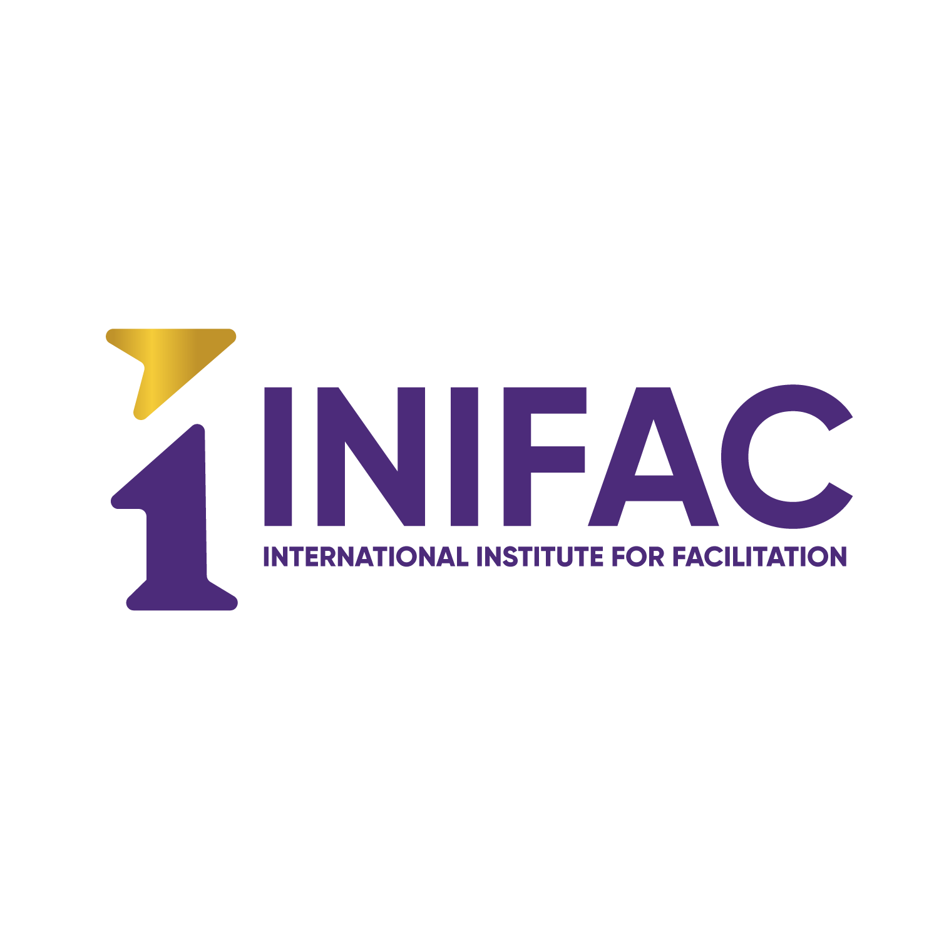

Example Language
for
Facilitation Services
Request for Proposal

Foreword

The International Institute for Facilitation (INIFAC) is pleased to produce this industry guide to support organizations and agencies that are looking for professional facilitation services. This is part of the INIFAC commitment to raising the standard of facilitation services in all sectors.

Introduction to this guide

The guide offers example content for an organization to use when facilitation services are required, and the organization wants to publish documentation and review submitted proposals. It uses a typical framework of a Request for Proposal (RFP) throughout the example content. It is expected that this content can equally be applied to other documentation such as Requests for Qualifications or even a Request for Intent.

This example language is designed to use in addition to the INIFAC Guide to Building a Better RFP and the Technical Proposal Question Response Form. This example language for an RFP serves three main purposes:

- Informing organizations on content scope to help guide their procurement.

- Providing organizations with appropriate descriptions of the skills and services required for professional facilitation delivery.

- Providing a benchmark, which will offer organizations the ability to validate suppliers’ capabilities for working in “people focused” activities such as focus groups, group facilitation, meeting facilitation and community consultation.

The International Institute for Facilitation

Today, we must confront business issues with efficiency and integration of human talent as we function in an ever-changing business climate. Organizations are finding that service providers who possess facilitation skills, are key contributors to productive, profitable, and satisfying outcomes. Yet how can you ensure that a service provider possesses a level of facilitator proficiency, which offers some form of risk mitigation to the sponsor organization?

To address this need of proven proficiency, The International Institute for Facilitation (INIFAC) was created.

Our Mission
We advance mastery in facilitation that helps individuals, groups and organizations around the world achieve collaborative results.

The purpose of the INIFAC Certification standards and competencies is to provide a measurement of the person’s facilitation knowledge and skills. It is also designed to provide clients with the credentials and confirmation that someone can help a group achieve outstanding results through a facilitated process.

As part of the certification development, we researched organizations and established six competencies and 30 sub-competencies for earning a Certified Master Facilitator credential. The assessment process uses the highest degree of rigor and consistency available by implementing defined scoring guidelines for each facilitation competency and sub-competency. This proven certification approach provides a valuable assessment for anyone intending to operate using a facilitative approach.

Our Partners In Facilitator Development Program (PIFD) is playing an unprecedented role in the facilitation industry. We are helping organizations implement their own internal Facilitator Development Program to assess their internal facilitators and track their progress and performance.

INIFAC provides this industry guide as part of its commitment to raising the standard of facilitation services offered to sponsor organizations in all sectors across the globe.

Objective

This industry guide to the content of supplier requirement documentation sets out foundation content, which may be modified and customized by sponsor organizations. By providing this resource as a content guide we hope that sponsor organizations will have a greater ability to reduce risks and increase quality of their selection when facilitation of people is part, or all, of their scope of work.

Disclaimer

While INIFAC has made every effort to ensure that the material within this guide is accurate, the International Institute for Facilitation will not be liable for any disputes, mistakes, errors, or omissions arising as a result of information contained in this guide.

Example Content

INTRODUCTION

General:
The <sponsor organization> is seeking proposals from qualified firms or individuals to assist us in Facilitation Services that may include work in the following areas: retreat planning and facilitation; group facilitation; strategic planning facilitation; conflict resolution; meeting facilitation; team building; group intervention; focus group facilitation, and community and public participation.

The purpose of this Request for Proposals (RFP) is to select the most qualified individual or firms to provide group facilitation services to <sponsor organization>.

Objectives and Scope of Work

- Example 1: The selected facilitator will be responsible for collaborating with staff to develop a detailed agenda for the 2020 City Council Strategic Planning Retreat, and for planning and facilitating meetings among staff and elected officials in order to deliver a dynamic experience that results in a clear strategic planning direction for City in the coming year. During the initial meeting, the consultant and Commerce will facilitate a discussion with the Committee members to (1) establish the process for selecting a Chair from within the membership; and (2) establish the Committee’s duties and responsibilities (e.g., Committee Bylaws).
- Between the first and second meetings, the consultant will assist the Committee members and Commerce staff with drafting the Committee Bylaws and implementing the Chair selection process.
- At the second meeting, the consultant will facilitate the voting and appointment for the Chair and the adoption of the Committee Bylaws. • The consultant will work with the Chair and Commerce to facilitate each subsequent quarterly meeting.
- By statute, the Committee will meet quarterly beginning in November 2022. Each meeting will be two to three hours, conducted in person and/or using Zoom or similar platform (see Meeting Logistics above). The Committee may also break out in smaller focus groups, as it deems necessary.
- The consultant will take meeting attendance and notes, develop meeting summaries, and will assist Commerce with making those available to the Committee members, stakeholders, and the public.
- Agenda Planning The consultant will assist Commerce staff by ensuring that the relevant agenda topics for each meeting are in place and have designated the appropriate amount of time, and that agenda topics meet the intent of the authorizing legislation and the concerns expressed by committee members

FACILITATOR ROLE DESCRIPTION

Primary Responsibilities are to:
- Work with key stakeholders to plan the workshop sessions, including providing input/advice into the purpose, product, participants, probable issues, process, and place.
- Provide facilitation of workshops including establishing ground rules, managing the discussion, keeping the group focused, managing group energy, addressing disagreements, reaching consensus, and closing the session.
- Documenting the results of the workshop.
- Manage any dysfunctional behavior or conflicts occurring during workshops
- Ensure that workshop objectives are met
- Measure workshop performance
- Agenda Planning: Work with the City Manager to design a detailed agenda for the retreat, including clear delineation of timing, as well as space, equipment, food, logistics and other inputs necessary for a successful meeting
- Pre-Meeting Research Meet with councilmembers and staff in order to develop the facilitator’s understanding of key issues, interpersonal dynamics, and other factors that should inform the group discussions at the Strategic Planning Retreat. This may be done by phone or video call.
- Meeting Facilitation Facilitate the retreat between/among staff and the City Council in order to create a pleasant, dynamic, and productive retreat experience for participants. Methods to streamline the synthesis of multiple viewpoints into a coherent strategic plan is encouraged.
- Meeting Summary In consultation with staff, produce a written document that summarizes the Council’s deliberations, including an overview document that lists City Council priorities in a summary format.

Experience Requirements:
- Must have significant experience in managing group facilitation such as workshops, retreats, strategic planning, meeting facilitation, team building, group intervention, community participation, stakeholder and community consultation, and focus groups. Specifically, more than 15 facilitation events for more than 7 different project sponsors and 4 different sponsor organizations.
- Must be able to identify potential conflicts/issues and have ability to effectively manage them.
- Possession of a Certified Master Facilitator™ certification or equivalent (and produce verification).
- A background in psychology or behavioral science would be an advantage.
- Demonstrated experience conducting engaging facilitation sessions virtually with small groups using collaborative tools and techniques
- Experience leading strategic innovation efforts within utilities preferred
- Support a culture of iterative thinking, continuous learning, and innovation
- 5 years of experience facilitating large and culturally diverse groups on sensitive and complex issues, including developing agendas with Chairs, and producing summary meeting notes.

Desired Personal Qualities: (consider just using the 6 competency statements and have a checklist in the back that includes the sub-competencies)

- A strong sense of presence
    - Bring compassion and authority to the room.
    - Are confident, energetic, and self-aware.
    - Convey warmth and caring.
    - Are able to adjust in their style to better serve the group.
- An ability to partner with their clients
    - Assess clients’ needs.
    - Collaboratively prepare sessions.
    - Are able to define and implement alternative processes when and as required.
- Skilled in communication
  - Actively listen.
  - Exceptional analytical thinking skills.
  - Ask questions that help groups to engage effectively.
  - Deliver instructions that are accurate, clear, and concise.
- Create and maintain a productive and safe environment
  - Leverage diversity of the group.
  - Maintain control of the session at an appropriate pace.
  - Guide a group through conflict.
  - Detect and resolve dysfunctional behavior.
- Consistently apply best practice techniques
  - Applied to all primary responsibilities including problem solving & decision-making
- Engage groups
  - Promote creativity.
  - Manage the energy in the room.

Process Experience

The facilitator must be experienced in the following processes critical to this RFP:

Consensus building
Specific Process Examples:
Familiarity with Design Thinking methodology (or a similar methodology) as it applies to the facilitation process. Proposals must include a detailed outline explaining how the preferred methodology would be applied.
Familiarity with Agile methodology and nomenclature (or a similar methodology) as it applies to the facilitation process. Proposals must include a detailed outline explaining how the preferred methodology would be applied.
Familiarity and understanding of applying Objective and Key Results (OKR) goal setting methodology (or a similar methodology) as it applies to the facilitation process. Proposals must include a detailed outline explaining how the preferred methodology would be applied.
Familiarity and understanding of applying Adaptive Leadership (or a similar methodology) as it applies to the facilitation process. Proposals must include a detailed outline explaining how the preferred methodology would be applied.

Industry Experience

While we recognize that skills in facilitation are significantly more important than experience in the industry, we seek a strongly skilled facilitator with a minimum of three assignments related to the following industry: ___________

Please provide at least three (3) references for similar work completed within the past twelve months (virtual, hybrid or in person are all acceptable).

Award Criteria
The award criterion for the requirement is based on the following:

Stage 1 – Selection Criteria

Offers must include a copy of the proposed facilitators’ resume or CV and any supporting documents including certifications. This will be used to establish that the proposed facilitator/s has/have experience in the personal specification stated above.

Please also submit real examples of agendas, documentation, reports, and other materials created for a facilitated session similar to the work requested in this RFP.

<insert sponsor organization specific evaluation criteria>

