Flip Chart Best Practices

Note: Read the Facilitation Manual for more information

ALWAYS CREATE your flipcharts for the meeting BEFORE the meeting. This helps make sure your handwriting is legible (yes, you, Logan!!) as well as to get you thinking more about the agenda.

ALWAYS have these flipcharts ready:
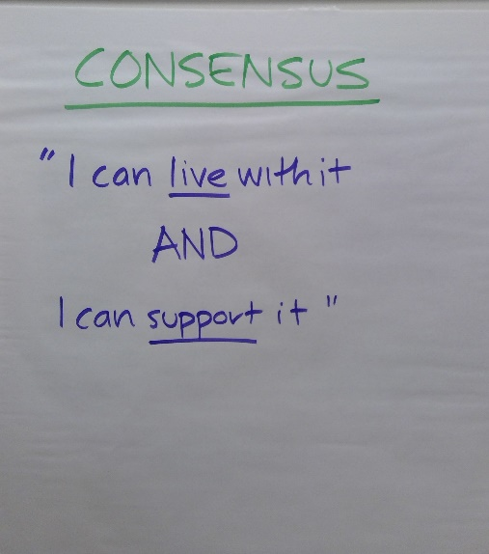
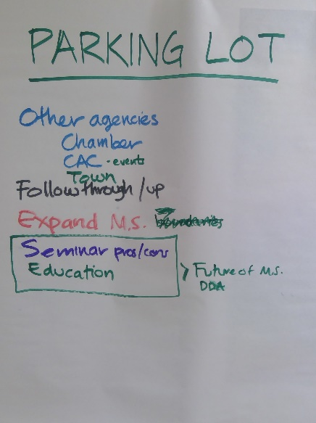
-Agenda
-Purpose
-Ground Rules
-Consensus
-Parking Lot
-Agreements
-Next Steps

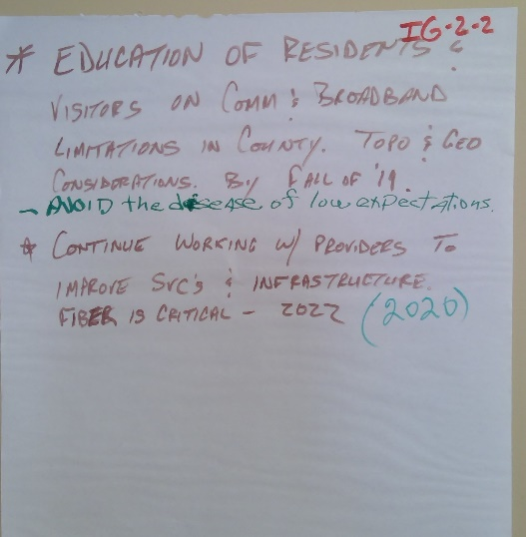
Then you can create the flipcharts that are specific to your meeting. Always LABEL the flip charts in the following way:
- Title of Flipchart on the top (i.e., Priorities, Values, Agenda…whatever the main topic of the flip chart is)
- If you move to another flipchart because the volume of the information, always title the flipchart the same, and start a numbering process at the top. For example:

- Priority is Infrastructure and you are currently creating some Goals for that Priority. You have three (3) Goals. Your label would be I (for Infrastructure) – G (for Goal) 1 – 1 (for first page). The second page of information for Goal 1 would be labeled I-G-1-2.

Note: if your handwriting is actually quite bad, you can have help from your clients (ask who would like to volunteer to write, have more small group breakouts where they write, etc)

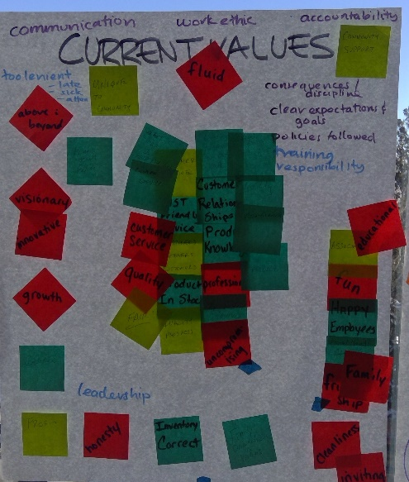
Always PHOTOGRAPH each flip chart for your records, and the client records.

Create a WALL of flipcharts as you peel them off – make them in order so they make sense and are easily seen.

Leave the original flip charts for the client.

