Crossing the River – My Favorite Team Building Activity
By Michael Wilkinson, CMF
Managing Director, Leadership Strategies, Inc.
Author, The Secrets of Facilitation and The Secrets to Masterful Meetings
Every trainer and facilitator has his/her favorite team building activity. Some facilitators like the more active interventions such as rope courses; others prefer the more “touchy-feely” ones like trust walks; still others like using blind-folded instruction, or simulations like Gold of the Desert Kings.
Of course the most appropriate team building activity for a group depends on a number of factors, including your overall purpose, the nature of the group, the amount of time you have, the limitations of the space, etc.
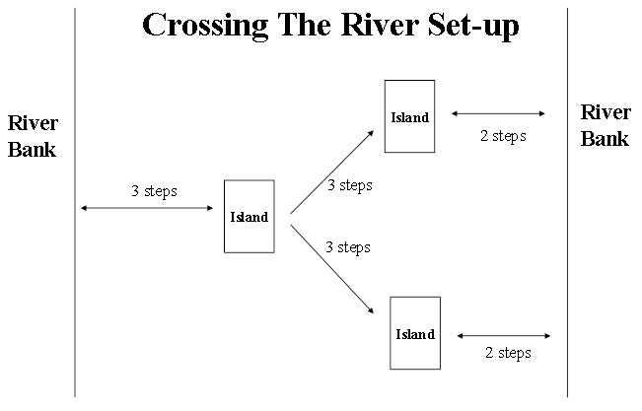
Yet, of all the team building activities I have experienced, my favorite by far is an activity called Crossing the River. I’ll describe the exercise first and then I’ll tell you why I think it is so great.

Objective
Have all members of the team cross the river at the same time.

Preparation
Create three islands by taping together four 8.5 x 11 sheets of paper for each island. Create a pebble for each person by cutting sheets of paper in half length-wise to form 4.25 x11 sheets. Create one rock (an 8.5 x 11 sheet) for every six participants. Tape off an open area at least 10 medium strides (25-30 feet) long and six strides wide. Place the islands as shown in the diagram.

Instructions
Have all participants stand on the left side of the bank and hand out a copy of the instruction sheet to each person and review the situation and rules together. Then give two minutes for questions. The clock starts after the last question is answered.

The Situation
You and your teammates are on one bank of a poisonous, deadly river. The river is so contaminated that if any part of a person’s skin or clothing touches the river, they will die instantly! Each of the people on your team must cross from one bank of the deadly river to the other. You have 20 minutes.

The Rules
- No part of a person’s skin, clothing or personal articles may touch the river. The only items that can survive in the river are islands, rocks and pebbles.
- Islands, rocks and pebbles are safe spots (touchable).
- Islands in the river may not be moved.
- Rocks may not be moved once placed in the river.
- Each team member owns a pebble.
- Only the pebble owner, may place a pebble in the river, take a pebble from the river, or move a pebble once it is in the river, and he/she may do so using his/her hand only.
- All team members must step out of the river at the same time.

Execution
During execution, pay close attention to group dynamics. Some items to be conscious of in particular follow.
Points for Observation
Communication
- How long did it take for there to be a single conversation going?
- Did everyone who wanted to speak get an opportunity to be heard?
- When suggestions were made, was a response given every time? (Or did some people’s suggestions get listened to while other’s were ignored?)
Planning
- Was a plan created? Who initiated the plan? How many people were involved in developing the plan?
- How was agreement reached? Did the group check to ensure understanding and agreement from everyone before acting on the plan?
- Did the plan provide a complete picture of how to start and how to end?
Execution
- Was there a leader or multiple leaders? How was the leadership chosen? Was the leadership followed?
- How willing were people to rely on one another, to help one another and physically support one another?
- Was the goal achieved? How much time was required? What was the key to achieving or not achieving the goal?
Debrief
At the completion of the exercise, debrief with the team. Have them identify their own observations. Be sure to offer your own observations as well. Following observations, have them identify their learnings, and how to apply their observations and learnings to the workplace.

Crossing the River is ideal for 8-16 people. If you have up to 24, you can choose several to be observers and assign them different sections of the Points for Observation. If you have more than 24, you can split into multiple teams that do the exercise all at the same time, each with their separate “rivers” they have to cross. I have done this with 16 teams simultaneously in a very large room. As each team completed, they let out a team cheer.
What makes Crossing the River so great for team building?
- The goal requires team planning and execution; the team has to come together for success.
- No one can do it on his/her own; the team either succeeds or fails together.
- The exercise breaks down barriers; it requires people to share their thoughts, share their resources, and share their space.
- And perhaps most interestingly, the time limit creates a sense of urgency that frequently results in people defaulting to the same behaviors that do in the workplace: those who typically takeover, do so in this exercise; people who drop out, also do the same; people who frequently serve as naysayers, often take on this same role when faced with Crossing the River.
For years I have been looking for a second team building exercise as good as this one. If you have one I loved to hear from you. I’ll share the best I get in a coming issue.
Michael Wilkinson is the Managing Director of Leadership Strategies – The Facilitation Company, and a much sought after trainer, facilitator and speaker.
He is a Certified Master Facilitator and a Certified Professional Facilitator. As a past president of the Southeast Association of Facilitators and a board member of the National Institute of Facilitation, Michael is a national leader in the facilitation industry. You can get more tips from either of Michael’s books, The Secrets of Facilitation or The Secrets to Masterful Meetings. You can receive a signed copy through our website.
56 Perimeter Center East, #103
Atlanta, Georgia 30346
770.454.1440
www.leadstrat.com
Crossing the RiverTeam Building Activity

