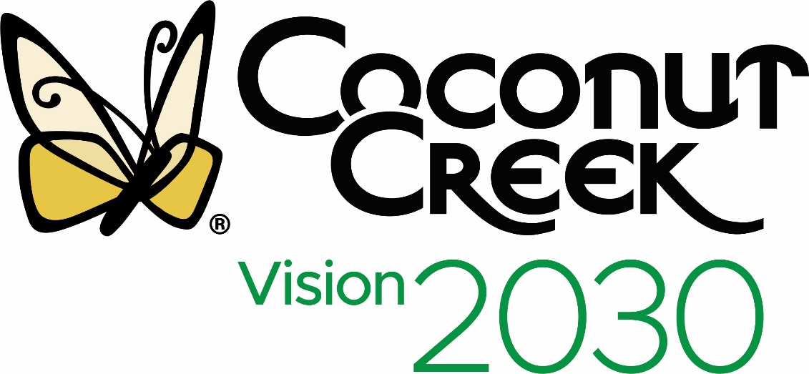
City of Coconut Creek
Community Engagement Strategies

Note: Assumes public health restrictions on in person engagement strategies, and public reluctance to engage with physical tools such as pens, paper, white boards and post it notes. We are recommending only the low or no cost options per City feedback! Blue background lists the online options, green background includes printed material.

Technique or Tool | Tool | Action Plan | Target Audience | Responsible Party | Additional Budget or Resources Needed
Online Community Forums | Zoom  Graphic Recorder | Use all engagement tools available (white boards, polls, chat rooms, share screen, videos, etc) for engagement |  | SBrand | 0
Online Advisory Group Meetings | Zoom | Same as above |  | SBrand | 0
Online Collaborative Tool | Miro (we will only have one board) | Use within online meetings as an engagement tool | Those who would respond well | SBrand | 0
Online Survey Tool | Survey Monkey | May need to offer a gift, or be entered into a drawing to get more participation | All | SBrand  Gift from City | 0
Videos | Adobe Spark, Animoto | Post on social media and website |  | City | 0
Online Walking Tours | Google Maps | For what? For where? |  | SBrand | 0
Social Media – create hashtag, create events and contests | Facebook | Posts  Live Stream Zoom |  |  | 0
 | Instagram | Posts |  |  | 0
 | You Tube | Post community meetings |  | City | 0
Website |  | Create a page for the strategic plan and updates, allow live streaming, video | All | SBrand if a separate website (can set up a Wix site)  City if current website | $ if the City needs to do technical changes to allow live streaming and/or set up. Note: need to confirm Florida meeting laws
School Online Courses |  | Ask for 15 minutes during a school session, read a series of questions, keep chat results | K - 12 | City  SBrand would prepare questions | 0
Flyers (for print or online) |  | Create 4 different versions of flyers to appeal to different audiences | Youth  Seniors  Business owners  ? | SBrand design  City print if needed | 0
Networking with Partners | Chamber, HOA’s, Boys and Girls Club, Faith Based, Senior Community, Library, Rec Center | Send outreach materials via online or mail | Clients, members, stakeholders, customers, students, employees of those partners |  | 0
Printed Materials: Newsletter or Postcard | Previously established channels (bills, inserts, etc) |  | Typically mature adults in the community who prefer to read information
Confidential Interviews | Zoom or Phone |  | Specific targeted audience as before | SBrand | 0

