Letter of Agreement – Consulting Services

This Letter of Agreement – Consulting Services (“Agreement”) is made between Canine Partners of the Rockies, a nonprofit organization in the State of Colorado (the “Client”), and SBrand Solutions LLC, a Colorado limited liability company having a principal office address of 2874 Blue Leaf Drive, Fort Collins, CO 80526 (“Consultant”) (together, the “Parties”).

The Consultant (SBrand Solutions) agrees to perform the consulting services set forth and described with particularity in Exhibit A (the “Consulting Services”).

Consultant’s total not to exceed fee for completing the Consulting Services is Four Thousand, Five Hundred dollars ($4,500.00). No costs for materials or travel expenses will be added to that amount. The Parties agree that the Consultant’s fee shall be paid in accordance with the following schedule:

- Amount billed per invoice within thirty (30) days following the completion of the Consulting Services, as described in Exhibit A (“Consulting Services”), and the Client’s receipt of a Consultant invoice for the Services.

If the Consultant fails to perform any of the Consulting Services, the Client will not be obligated to pay consulting charges. If the Client cancels any facilitated meeting included in the Consulting Services five (5) business days or less before the scheduled date, the Client will either need to reschedule the meeting or the Consultant will receive a 25% cancellation fee.

Any changes to this Agreement must be made in writing and executed by both Parties. The laws of the State of Colorado shall govern this Agreement.

Canine Partners SBrand Solutions LLC, a Colorado limited liability company

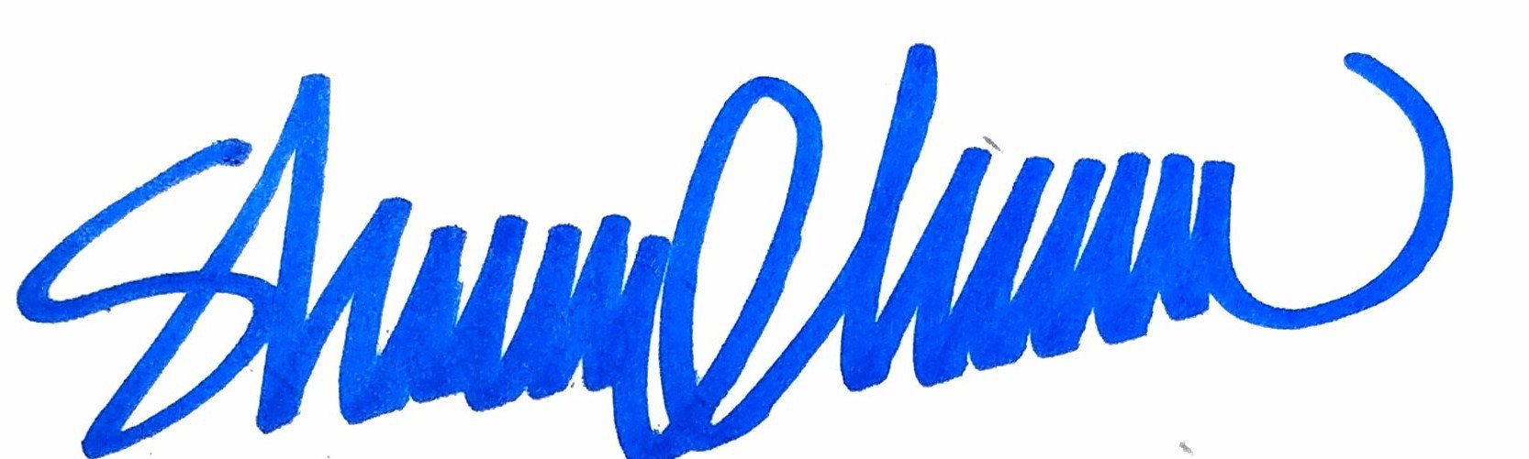
By: By:
_____________________

Sheryl Trent, Owner
sheryl@sbrandsolutions.com
(970) 208-6633

Exhibit A
Consulting Services

SBrand Solutions LLC, a Colorado limited liability company

Consultant agrees to provide the following services. The facilitation sessions will be virtual or in person depending upon the time and date.

All logistical emails, phone calls or Zoom meetings as needed.

Three (3) virtual planning sessions with Executive Director
Content creation for Strategic Plan
Content creation for Implementation Plan

One (1) two hour facilitated session with Board
Work session format to provide input on Strategic Plan

One (1) one hour facilitated session with Board
For Plan adoption

Completed Strategic Plan Document up to 16 pages
Includes graphic design and layout
Content provided by Client
Three revisions
Full graphic and completed files
Any needed changes for six months post adoption

Completed Implementation Plan document
Xcel or Word format
Formatted and completed based on content provided by Client

TOTAL NOT TO EXCEED FEE for Consulting Services:
$4,500.00

